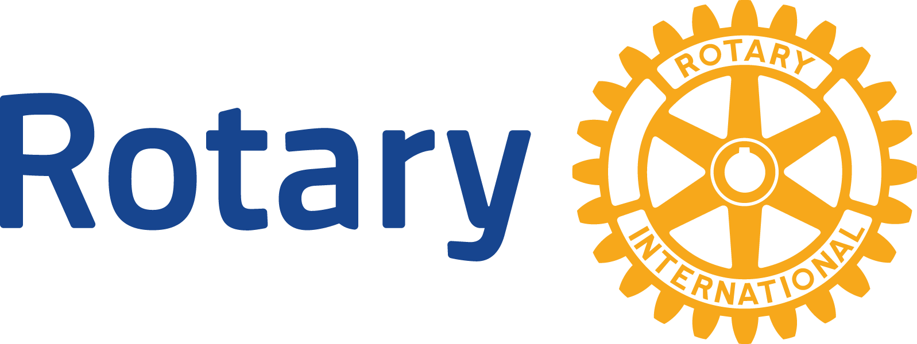
- If you have created an official logo through the RI Branding Center for your club, use it in place of standard logo. If not, leave the standard logo and list club name with address below.
- Fill in all yellow-highlighted information
- Keep information concise, but include the who, what, when, where and why
- If not on Facebook, delete the graphic and text
- Delete this box and save your file with a descriptive filename before issuing
- Need help? Contact District PR Chair at mike.antiporda@rotary5520.org.

Media Contact:

Your PR Chair or other contact
Your phone number
Your e-mail address

Your Club Name
Your Address
Your City, State, Zip
Your Web Site Address Here

“Like” us on Facebook!

For Immediate Release

Title

CITY, STATE, DATE – Text

About YOUR ROTARY CLUB NAME
Your Rotary Club Name is part of Rotary District 5520. The district is the largest geographic district in the continental United States, encompassing the state of New Mexico and west Texas.
About Rotary
Rotary brings together a global network of volunteer leaders dedicated to tackling the world’s most pressing humanitarian challenges. Rotary connects 1.2 million members of more than 34,000 Rotary clubs in over 200 countries and geographical areas. Their work impacts lives at both the local and international levels, from helping families in need in their own communities to working toward a polio-free world. For more information, visit Rotary.org.
###

